**MODULE 4: CSS AND CSS3**

Q1: What are the benefits of using CSS?

-There are many advantages of using CSS like:-

1. It saves time.

2. Consistent design.

3. It is easy to maintain.

4. CSS possesses flexible positioning of design elements.

Q2: What are the disadvantages of CSS?

-Some of the disadvantages are as follows:-

1. There are certain cross browser issues.

2. Limited security is one of the main loopholes.

Q3: What is the difference between CSS2 and CSS3?

|  |  |
| --- | --- |
| **CSS2** | **CSS3** |
| -There is no backward compatibility with CSS2. | -There is backward compatibility with CSS3. |
| -Only web safe fonts can be used. | -Special fonts can also be used such as Google Fonts and Type Cast. |
| -The concept of simple selectors were present. | -The selectors were called as a sequence of simple selectors.com. |
| -It doesn’t support the border-box property. | -It supports the border-box property. |

Q4: Name a few CSS style components.

-Few CSS style components are:

1. Inline CSS
2. External CSS
3. Values
4. Properties
5. Selectors

Q5: What do you understand by CSS opacity?

-Opacity refers to the transperancy of the elements which ranges from 0 i.e totally transparent to 1 i.e totally opaque.

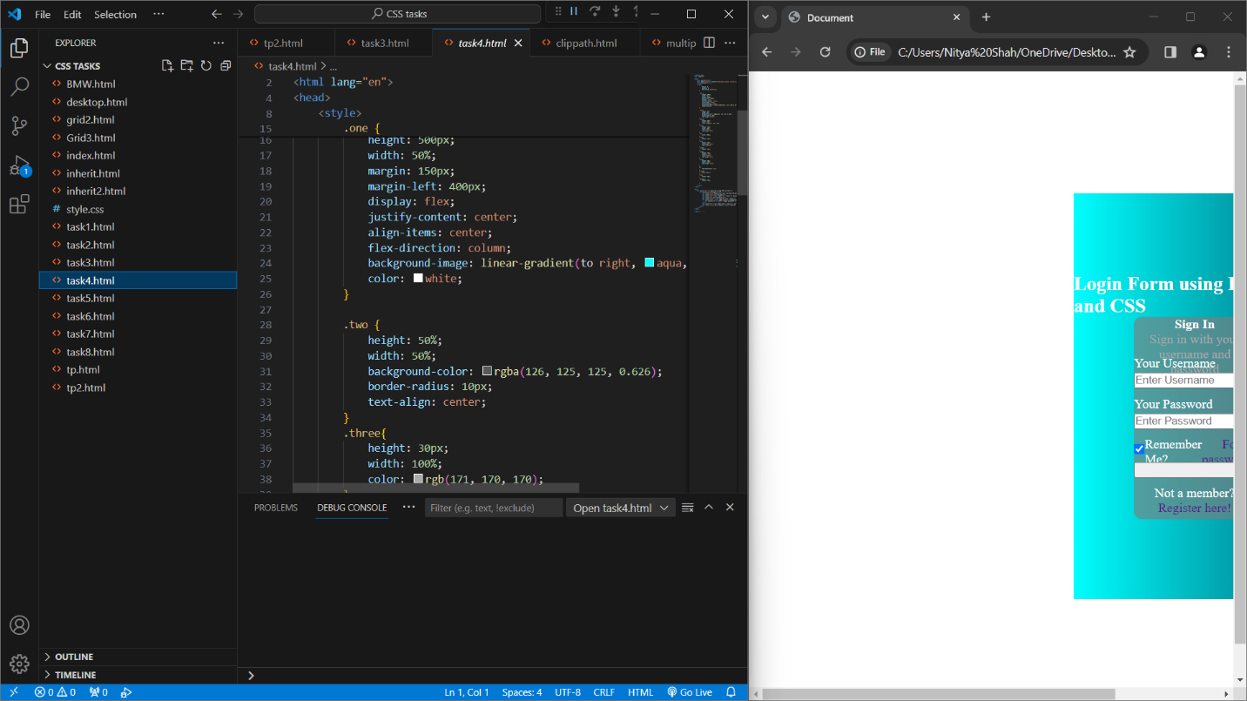

Q6: How can the background color of an element be changed?

-By using the property of background color in style.

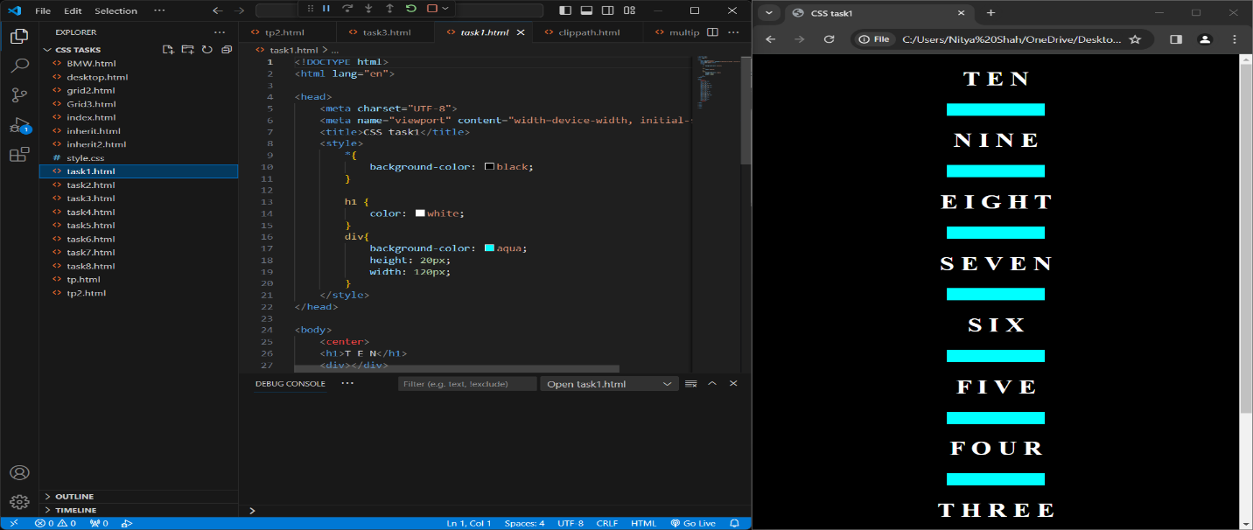

Q7: How can image repetition of the backup be controlled?

-By using the property of background-repeat=no repeat; .

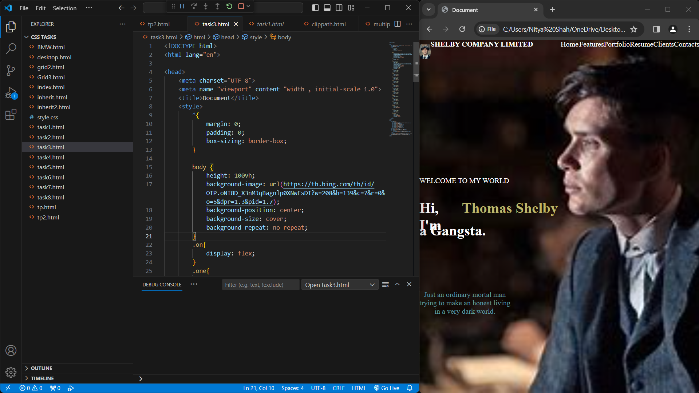

Q8: What is the use of the background-position property?

-Background-position property is used to control the alignment (both vertical and horizontal) of the image.

Q9: Which property controls the image scroll in the background?

-Background attachment is the value that controls image scroll in the background. It can be assigned with values like fixed,scroll or local.

Q10: Why should background and color be used as separate properties?

-It is so because background color property is used to give color to the background while color property is used to give color to the text. Hence, they are separately used.

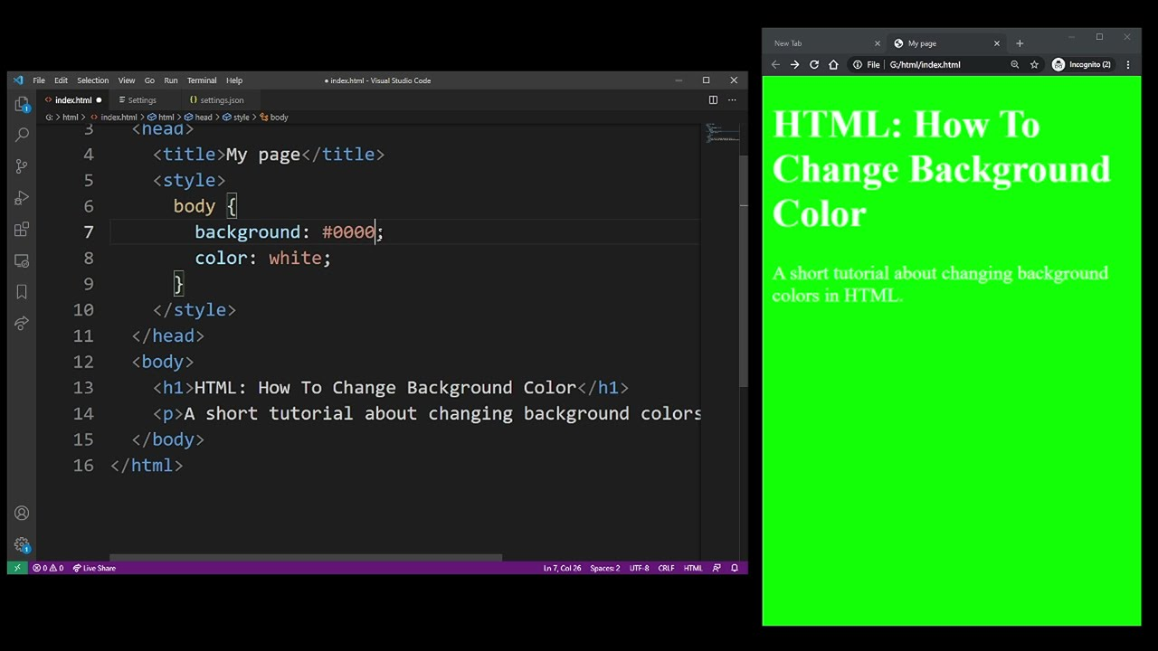

Q11: How to center block elements using CSS1?

- To center block elements using CSS1, you need to do two things:

* Set the width of the element to a value less than 100% of its container. This will create some space around the element.
* Set the left and right margins of the element to auto. This will automatically center the element within the available space.

For example, you can use the following CSS code to center a <div> element:

Q12: How to maintain the CSS specifications?

-Specifications define how properties and features must be implemented by the browsers.

Q13: What are the ways to integrate CSS as a web page?

-The ways to integrate CSS as a web page are:

1. Inline CSS
2. External CSS
3. Internal CSS

Q14: What is embedded style sheets?

-Embedded style sheet is a way of applying CSS to a HTML document by using <style> tag in <head> section.

Q15: What are the external style sheets?

-External style sheets are separate files that contain CSS rules to be applied to an HTML document.

Q16: What are the advantages and disadvantages of using external style sheets?

-Advantages of external style sheet are as follows:

1. They improve maintainability and code organization, as the CSS code is in another file with clear structure.
2. They enhance reusability across various html pages.
3. Same style sheet can be applied to different web elements.

-Disadvantages are as follows:

1.They may cause rendering issues until external CSS is loaded.

2.Increase download time if there are multiple CSS files.

Q17: What is the meaning of the CSS selector?

- It is used to match one or more element that you want to style in html.

Q18: What are the media types allowed by CSS?

-Media types are a way of specifying how CSS styles will be applied to other devices like screen, printer etc.

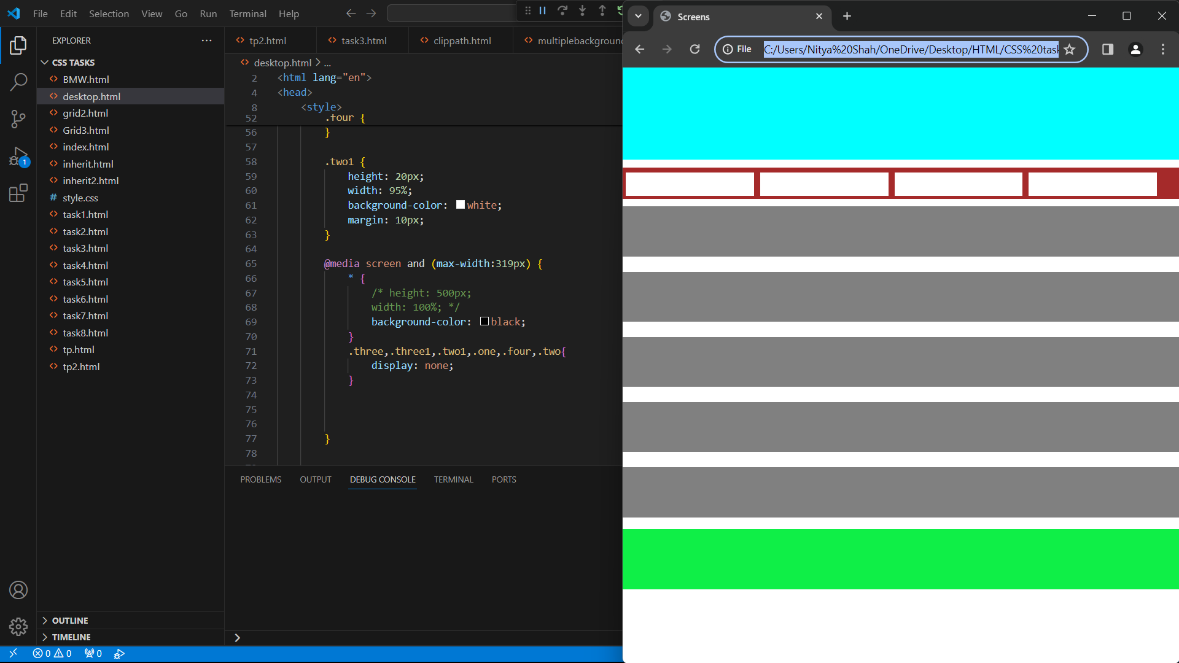

Q19: What is the rule set?

- A rule set is a collection of rules that decide the logics or criteria for a specific task to take place or perform.